**University of Zawia Journal of Educational   
and Psychological Sciences (UZJEPS)**

**Volume 13, Issue 1, (2024), pp253-269,ISSN:3078-2899**



**Choosing The Participants In Tesol (Teaching English To Speakers Of Other Languages) Research**

Fathi M.Agill , Ibtisam S Alahmer

Libyan Academy

College of Engineering Technology-Gherian

Email: [fathi.akle@academy.edu.ly](mailto:fathi.akle@academy.edu.ly) ibtisam.alahmer.10@gu.edu.ly

Received*: 13/03/2024 /* Accepted*: 30/03/2024* /Available online*: 30/06/2024 /* DOI 10.26629/uzjeps.2024.14

**ABSTRACT**

This paper aims to focus on the selection of TESOL research participants. It was noted that many EFL postgraduate students face problems regarding the selection of participants for their TESOL research. Therefore, this paper reviews the literature on sampling research in general and within the discipline of TESOL. The paper clarifies the terms and strategies used in selecting research participants. By understanding and applying the principles and methods of sampling designs, EFL postgraduate students can enhance the validity and reliability of their research findings and contribute to the advancement of knowledge in the field of TESOL research.

**Keywords**: TESOL (Teaching English to Speakers of Other Languages), Selection of research participants, EFL post graduate students

**اختيار المشاركين في أبحاث تدريس اللغة الإنجليزية لغير الناطقين بها**

فتحـــي محمد عقل1، الأكاديمية الليبية

ابتسام اشهوب الأحمر2 ، كلية التقنية الهندسية، غريان

Email: [fathi.akle@academy.edu.ly](mailto:fathi.akle@academy.edu.ly) ibtisam.alahmer.10@gu.edu.ly

|  |  |  |
| --- | --- | --- |
| تاريخ الاستلام: 12/03/2024م | تاريخ القبول: 30/03/2024م | تاريخ النشر: 30/06/2024م |

الملخص:

تهدف هذه الورقة إلى التركيز على اختيار المشاركين في أبحاث تدريس اللغة الإنجليزية لغير الناطقين بها. وقد لوحظ أن العديد من طلاب الدراسات العليا في اللغة الإنجليزية كلغة أجنبية يواجهون مشاكل فيما يتعلق باختيار العينة لأبحاثهم، تستعرض هذه الورقة الأدبيات المتعلقة بأبحاث أخذ العينات بشكل عام وضمن تخصص (تدريس اللغة الإنجليزية لغير الناطقين بها) وتوضح الورقة المصطلحات والاستراتيجيات المستخدمة في اختيار المشاركين في البحث. من خلال فهم وتطبيق مبادئ وأساليب تصاميم أخذ العينات من هذه الورقة، يمكن لطلاب الدراسات العليا في اللغة الإنجليزية كلغة أجنبية تعزيز صحة وموثوقية نتائج أبحاثهم والمساهمة في تقدم المعرفة في مجال أبحاث تدريس اللغة الإنجليزية لغير الناطقين بها.

**الكلمات المفتاحية**: TESOL تدريس اللغة الإنجليزية لغير الناطقين بها, اختيار عينة البحث, طلاب الدراسات العليا في اللغة الإنجليزية كلغة أجنبية

**Introduction**

Sampling design is an essential process in research methodology that involves selecting a representative subset of a larger population to study and draw valid conclusions from. Sampling design is used in TESOL research, which is a field of research focused on language education. The paper defines TESOL and explains the selection of participants in TESOL research. Population and sampling strategies are highlighted in details. The types of sampling and sampling size are explained both in general and in relation to the field of TESOL research. Finally, the paper concludes with a diagram summarizing the sampling process and presenting the overall conclusion.

**1. What is TESOL?**

TESOL stands for Teaching English to Speakers of Other Languages, which is a field of research focused on language education for non-native speakers of English. TESOL research involves investigating various aspects of language teaching and learning, such as language acquisition, language pedagogy, teacher training, and assessment. The goal of TESOL research is to improve the quality of English language education for nonnative speakers and to promote cross-cultural communication (Lee and Kim, 2020).

1. **How to select participants in TESOL research study?**

One of the important steps in TESOL research is determining the sample design. As a researcher, it is important to determine the specific characteristics of the people you need to communicate with (Dawson, 2002). During the preparation of your research, you identified and selected participants who could provide the desired information (Dawson, 1993). Therefore, when selecting participants for your research, there are two commonly used survey methods in several countries to gather information about the population:

1. Census Method or Parametric method
2. Sampling method or Non-parametric method (Pandey,P.,Pandey,M.,2021).

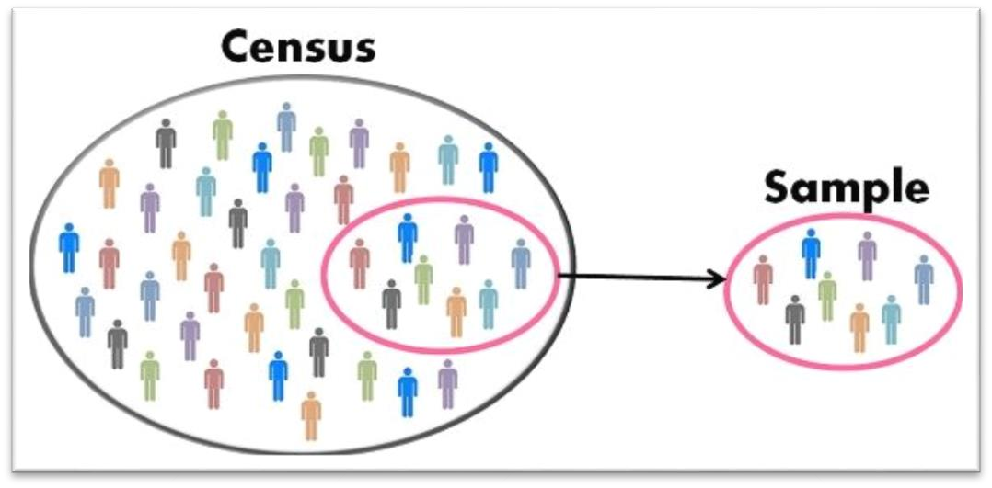

(Surbhi S,2017)

**2.1 Census or parametric method:**

To explain census method, it is necessary to discuss the population in the context of sampling design. The population refers to the group of individuals or objects that the researcher is interested in studying. The population can be defined in various ways depending on the research question, such as a geographic area, a particular demographic group, or a specific time period (Babbie, 2016 and Kothari, 2004).

A census method is a numerical list that examines every individual of a population. In other words, a census involves studying each component, everyone, or everything in a population. Additionally, it provides precise and accurate data about the entire universe (Pandey, P., Pandey, M., 2021).

The census method has several advantages. Firstly, it is particularly valuable for intensive studies where a comprehensive understanding of a population is required. Collecting data from every individual or entity within a given population allows the census method to provide a detailed analysis that reveals nuanced patterns and trends. Furthermore, the census method is recognized for its reliability and accuracy in generating findings. With data collected from the entire population, there is minimal sampling error, leading to more precise and dependable results. However, there are also notable disadvantages associated with the census method. One such drawback is its costliness, primarily due to the need to cover a large population size. Conducting a census requires substantial financial resources to reach and collect data from every individual or entity within the target population. Moreover, the census method requires a significant investment of time and human resources (Nandasisa, n.d.).

**2.2. Sampling method or Non-parametric method:**

Selecting a subset of contributors to represent the entire population is a common practice in research. Furthermore, researchers select a sample from a large group of people to obtain results in their research (Dawson, 2002). In other words, sampling methods involve selecting a small number of individuals from a larger population (Pandey, P., Pandey, M., 2021). Sampling methods are used in both quantitative and qualitative research. In quantitative research, findings can be generalized to the whole population if the sample is accurately selected using appropriate procedures (Dawson, 2002). However, many qualitative researchers do not aim to generalize their work to the entire research population. Instead, they focus on describing or explaining phenomena within a smaller group of people (Dawson, 2002, p. 47). Therefore, if the sample is not selected precisely, the results may be misleading (Dawson, 2002).

Sampling methods offer several advantages. Since sampling methods focus on studying a smaller group of individuals or entities within a population, the data collection process is limited, leading to reduced expenses. Another advantage of sampling methods is the ability to obtain results quickly. By studying a smaller sample, researchers can gather data more efficiently, allowing for faster analysis and interpretation. This expedited timeline can be particularly beneficial in situations where timely results are necessary.

However, there are also disadvantages associated with sampling methods. One such drawback is the potential lack of accuracy in the results. Since the conclusions drawn from sampling methods are based on a small number of objects taken from the entire population, there is a possibility that the results may not accurately represent the true population. The limited sample size increases the likelihood of sampling error and may introduce bias into the findings.

Additionally, selecting a sample that adequately represents the population can be challenging. It is not always easy to choose a sample that possesses all the characteristics of the larger population. This can lead to a lack of representativeness and limit the generalizability of the findings (Pandey, P., Pandey, M., 2021).

In summary, while sampling methods offer advantages such as cost-effectiveness and quicker results, they also have limitations, including potential inaccuracies and difficulties in selecting a representative sample. Researchers should carefully consider these factors when selecting the appropriate method for their study.

|  |  |  |
| --- | --- | --- |
| BASIS FOR  COMPARISON | CENSUS | SAMPLING |
| Meaning | A systematic method that collects and records the data about the members of the population is called Census. | Sampling refers to a portion of the population selected to represent the entire group, in all its characteristics. |
| Enumeration | Complete | Partial |
| Study of | Each and every unit of the population. | Only a handful of units of the population. |
| Time required | It is a time consuming process. | It is a fast process. |
| Cost | Expensive method | Economical method |
| Results | Reliable and accurate | Less reliable and accurate, due to the margin of error in the data collected. |
| Error | Not present. | Depends on the size of the population |
| Appropriate for | Population of heterogeneous nature. | Population of homogeneous nature. |

**3.The following table clarifies the comparison between census and sampling:**

(Surbhi S, 2017:60).

In general, to determine the most suitable method for a specific TESOL research study, researchers should consider the research objectives, the population size, available resources, and the desired level of generalizability. It is recommended to consult relevant literature on research methodology in TESOL to gain insights into best practices and to justify the chosen method based on the specific research aims. Census is not better than sampling and vice versa (Cohen, L., Manion, L., & Morrison, K. 2018).

3- **The main types of sampling?**

Basically there are two main types of sample:

* + 1. probability sampling.
    2. Non-Probability sampling.
  1. **probability sampling**

In the research universe, every individual has the opportunity to be selected. Furthermore, researchers use these types of samples to illustrate, predict, or gain a broader understanding of the research population (Dawson, 2002). Random sampling, (probability sampling) techniques, is commonly employed in TESOL research to ensure the representativeness of the selected sample. Probability sampling methods assign a known and non-zero chance to each member of the population for inclusion in the sample, thereby enhancing the generalizability of the findings. One commonly used probability sampling technique in TESOL research is stratified random sampling. Another probability sampling technique employed in TESOL research is cluster sampling (Cohen, L., Manion, L., & Morrison, K., 2018).

Types of probability of sampling:

3.1.1 Simple random sample:

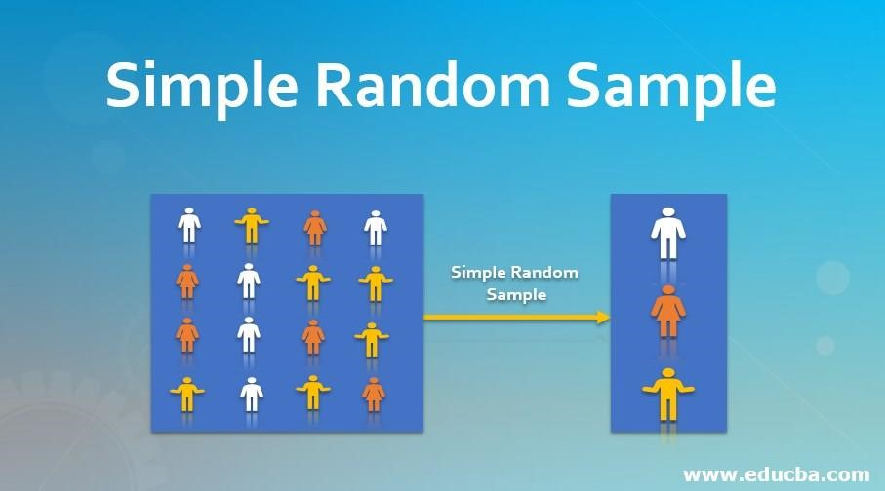

(Taherdoost, H., 2016)

A sample which being picked randomly is defined as simple random sample. That is, every component of the universe has the same and self-determining opportunity of being included in the sample (Pandey, P., Pandey, M.,2021).

**3.1.2** Cluster **sample:**

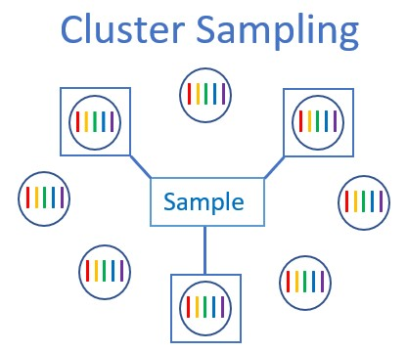

(

Cluster Sampling,

2021)

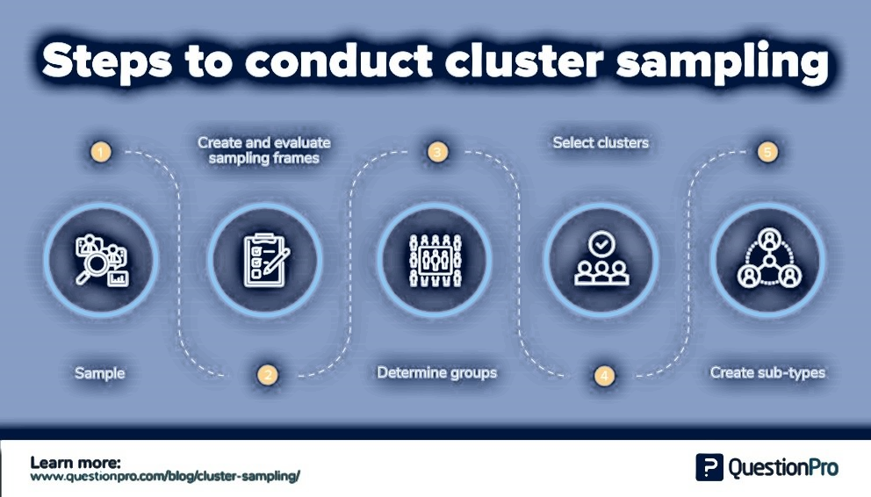(QuestionPro, 2018)

Cluster sampling is the division of the population into smaller groups of people. After that, the researcher selects randomly among these groups to form up a sample (Pandey, P., Pandey, M.,2021).

**3.1.3. Quasi-random sample or systematic sample:**

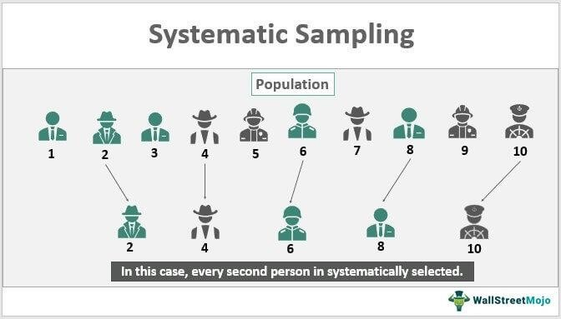

(WallStreetMojo,2020)

Systematic sampling considered to be advanced than the simple random sampling.by this method, the population should have the entire information. Therefore, the details of each member of the population must be in a form of a list in any systematic way (Pandey,P.,Pandey,M.,2021).

**3.1.4. Stratified random sample.**

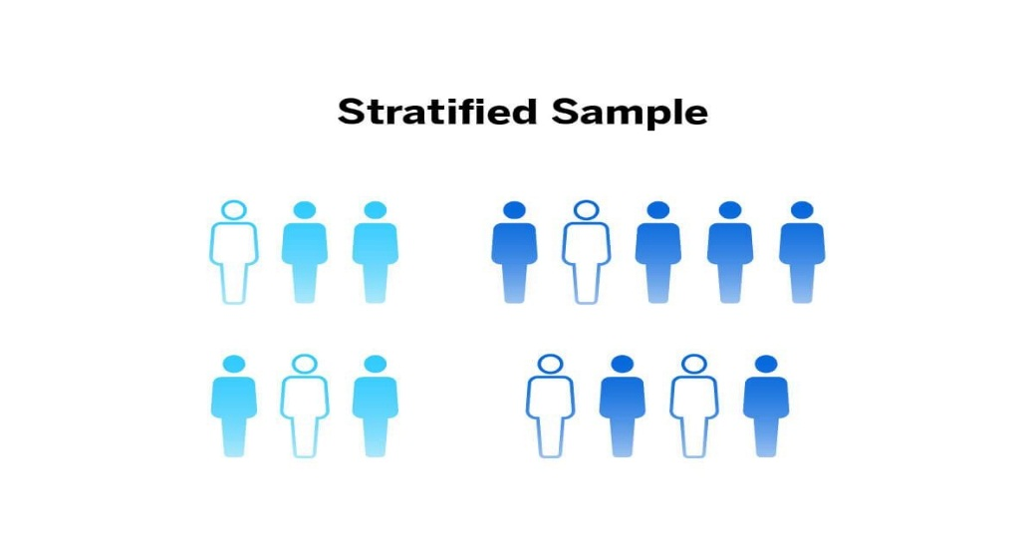

(Qualtrics, n.d.)

Stratified sampling is the division of the population into small sup groups defined as strata. It based on the same members' features, for example, income or educational achievement (Pandey, P., Pandey, M.,2021).

3.1.5. **Disproportionate stratified sample.**

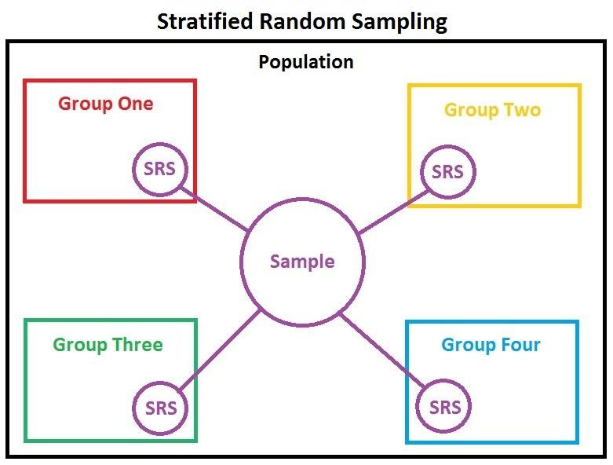

(Contributors, 2019)

Disproportionate stratified sampling means the researcher randomly chooses members of the sample from each group. This method of sampling is more effective for comparing strata which have different error opportunities. It is less effective for determining population characteristics (Pandey, P., Pandey, M.,2021).

**3.2 Non-Probability sampling:**

"Purposive samples (or non-probability samples) are used description rather than generalization is the goal. In this type of sample, it is impossible to identify the probability of one person being included in the sample." (Dawson,2002;48-49). Non-probability sampling is a research method used in TESOL (Teaching English to Speakers of Other Languages) to select participants based on criteria other than random chance. This approach is often employed when researchers aim to investigate specific characteristics or groups within the TESOL context.

Types of non-probability samples:

3.2.1 **Quota sample**:

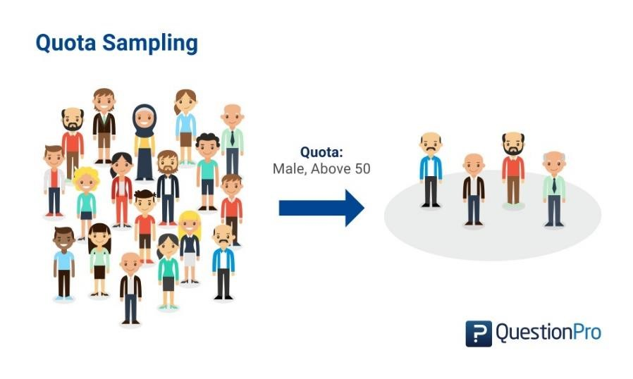

(Deep,AI, 2019)

Researchers divide the population into groups, then convert sample units until they reach their quota. These elements share specific characteristics, determined by the researcher preceding to making their strata. Therefore, quota sampling is random and probably to figure in community surveys (Pandey, P., Pandey, M.,2021).

3.2.2 **Snowball sample**

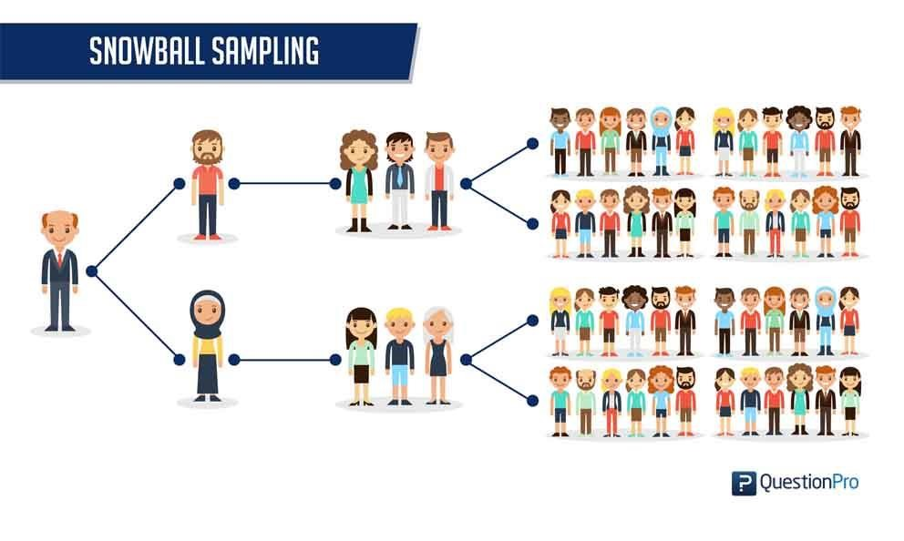

(QuestionPro, 2018)

Snowball sampling is a sample which grows by the observation or study continues (Pandey,P.,Pandey,M.,2021).

3.2.3 **Convenience sample, Haphazard or accidental sampling:**

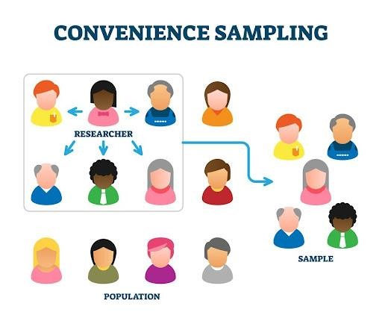

(Blog, 2021)

Convenience sample also called incidental, accidental, or haphazard. It is practical to those taken samples which are most frequently available. It is the most commonly used sampling technique as it’s incredibly prompt, uncomplicated, and economical. In many cases, members are readily approachable to be a part of the sample (Pandey,P.,Pandey,M.,2021). In TESOL research, convenience sampling is frequently utilized due to practical considerations. For example, a researcher might select participants based on their accessibility or proximity, such as students from a particular language school. While this method may lack generalizability, it allows for efficient data collection within a specific context. As an example, Smith (2018) conducted a TESOL study using convenience sampling, selecting participants from a language school based on their availability and willingness to participate. The researcher acknowledged the limitation of generalizability but emphasized the practicality of data collection within that specific educational setting

3.2.4 **Heterogeneous samples:**

Where there is a deliberate approach to select people who are alike in some significant details (Dowson,2002). Heterogeneous samples, a common type of non-probability sampling in TESOL research, allow for the inclusion of diverse language learners (Smith & Johnson, 2017).

3.2.5 Purposive sampling:

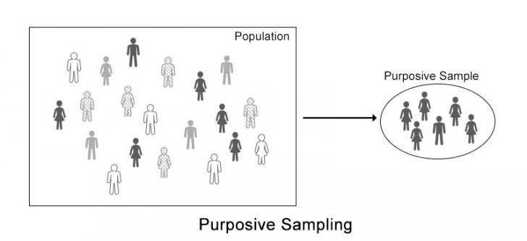

(Dudovskiy, 2022)

In purposive sampling, personal judgment needs to be used to choose cases that help answer research questions or achieve research objectives (Dudovskiy, 2022). Purposive sampling is another non-probability sampling technique employed in TESOL research. Researchers deliberately choose participants who possess certain characteristics relevant to their study. For instance, a study focusing on the impact of teaching methods may purposefully select participants with varying levels of teaching experience. Johnson et al. (2020) employed purposive sampling to gather a diverse group of participants with varying levels of teaching experience. This allowed the researchers to explore the impact of teaching methods on language acquisition, drawing on the expertise and perspectives of different educators.

**3.3 The following table summarizes the key differences between probability and non-probability:**

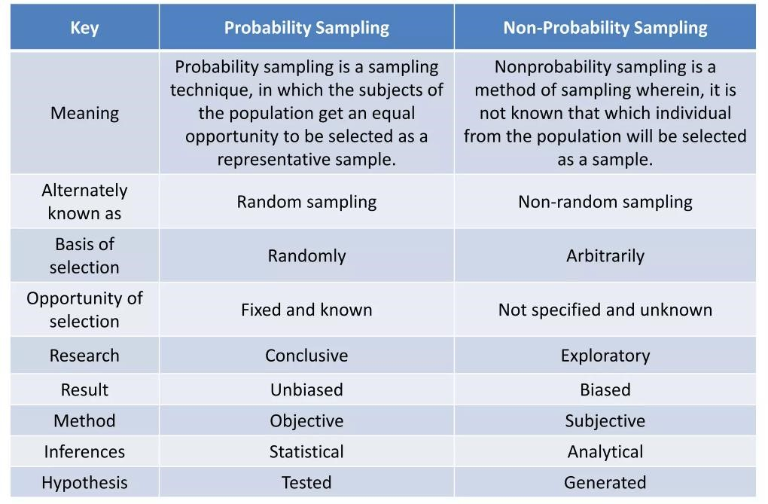

(Aniruddha, D, 2017)

1. **Determining the most appropriate type of sampling in TESOL research:**

The most appropriate sampling method in TESOL research depends on various factors, including the research question, the population of interest, and the available resources. TESOL research can employ different sampling techniques, such as random sampling, stratified sampling, convenience sampling, or purposive sampling. For instance, when examining the effectiveness of a specific teaching method in TESOL classrooms, researchers may opt for a purposive sampling method to select participants with relevant experience. Conversely, when studying the overall language proficiency of non-native English speakers, researchers may utilize a random sampling method to select participants from a larger population. According to Dörnyei and Ushioda (2011, pp. 86-87), selecting the appropriate sampling method in TESOL research should consider the research question and the population of interest. Johnson and Onwuegbuzie (2004) suggest that mixed methods research can be particularly useful in TESOL, as it allows researchers to combine different sampling techniques and data collection methods to address complex research questions. Additionally, Creswell (2014) notes that sampling design should also take into account practical considerations, such as resource availability and the feasibility of obtaining a representative sample.

1. **Sample size:**

As a result, the great the sample the more precise your findings, in case of quantitative research. The researcher should keep in mind these issue. The determination of the sample size in research depends on various factors. Firstly, the type of research being conducted plays a significant role. In quantitative surveys, it is typically necessary to reach out to a larger number of people compared to qualitative research. This is because quantitative studies often aim to establish statistical relationships and require a sufficient sample size to achieve reliable results. Additionally, the desired use of the research results is an important consideration. For instance, if the intention is to make broad comparisons or draw conclusions about a population, a larger sample size is generally preferred. This is particularly relevant when constructing extensive measurements between organizations or studying large-scale phenomena.

In quantitative research, a larger sample size generally leads to more precise findings. However, researchers must also consider practical constraints. Inadequate time and limited financial resources may restrict the ability to include a massive number of participants in the study. It becomes crucial to strike a balance between the desired sample size and the available time and resources.

Another scenario that researchers need to be mindful of is the possibility of null results. In such cases, where the expected effect or relationship is minimal or nonexistent, selecting a larger sample size can help improve the statistical power of the study. By increasing the number of participants, researchers can enhance their ability to detect even small effects or differences.

Statistical approaches useful in sampling size which essential for accuracy and the capability to make broad views, according to extensive quantitative research (Dowson,2002). The aim of sampling size is making conclusions about the population from a sample (Singh and Masuku, 2014). Additionally, determining the appropriate sample size for TESOL (Teaching English to Speakers of Other Languages) research depends on various factors such as the research design, research questions, statistical considerations, and desired level of precision. While there is no one-size-fits-all answer, researchers can refer to established guidelines and consider statistical power analysis to determine an adequate sample size for their specific study (Cohen, L., Manion, L., & Morrison, K. 2018).

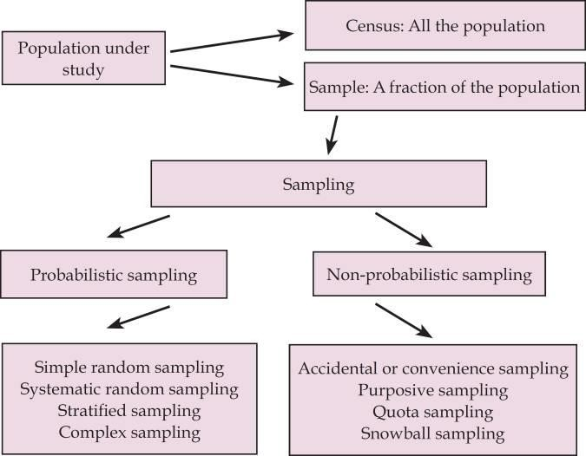

(Martínez-Mesa et al., 2016)

1. **Conclusion:**

In conclusion, the process of selecting participants in TESOL research is a critical aspect that significantly influences the validity and generalizability of study findings. This review has explored various considerations and methodologies employed by researchers in the field. It is evident that careful attention must be paid to factors such as sample size and participant characteristics. Researchers must strike a balance between the need for representative samples and practical constraints. As TESOL continues to evolve, future research should continually refine and innovate participant selection methodologies, ensuring that studies contribute meaningfully to the enhancement of language teaching and learning practices. Ultimately, the success of TESOL research lies not only in the rigor of its methodologies but also in the thoughtful and deliberate selection of participants that aligns with the specific objectives and nuances of the study.

List of References:

* + - 1. Aniruddha Deshmukh (2017). Sampling - Probability Vs Non-Probability.

[online] Available at: https://pt.slideshare.net/AniruddhaDeshmukh2/sampling-probability-vsnonprobability/4 [Accessed 2 Nov. 2022].

1. Anon, (n.d.). A complete guide to sampling techniques – HotCubator | Learn| Grow| Catalyse. [online] Available at: [https://hotcubator.com.au/research/acomplete-guide-to-sampling-techniques/[](https://hotcubator.com.au/research/a-complete-guide-to-sampling-techniques/)Accessed 2 Nov. 2022].
2. archive.unu.edu. (n.d.). Section 4: Selecting the study participants. [online]

Available at: <https://archive.unu.edu/unupress/food2/UIN03E/UIN03E04.HTM>[Accessed 2 Nov. 2022].

1. Babbie, E. (2016). The basics of social research. Cengage Learning. (p. 224)
2. Creswell, J. W. (2014). Research design: Qualitative, quantitative, and mixed methods approaches. Sage publications. (p. 191-192).
3. Cohen, L., Manion, L., & Morrison, K. (2018). Research methods in education. Routledge.
4. Cohen, L., Manion, L., & Morrison, K. (2018). Research Methods in Education. In this book, the authors discuss sample size determination in educational research and provide insights into power analysis and effect size estimation.
5. Dawson, C., 2002. Practical research methods: A user-friendly guide to mastering research. How to books.
6. Dawson, S., Manderson, L. and Tallo, V.L., 1993. *A manual for the use of focus groups*. Boston: international Nutrition foundation for developing countries.
7. Dörnyei, Z., & Ushioda, E. (2011). Teaching and researching motivation.

Pearson Education. (p. 86-87)

1. Dudovskiy, J. (2022). *Purposive sampling*. [online] Business Research Methodology. Available at: https://research-methodology.net/sampling-inprimary-data-collection/purposive-sampling/[Accessed 2 Nov. 2022].
2. Johnson, R. B., & Onwuegbuzie, A. J. (2004). Mixed methods research: A research paradigm whose time has come. Educational researcher, 33(7), 14-26. (p. 20)
3. Johnson, B., Anderson, C., & Davis, E. (2020). Teaching Methods and Language Acquisition: A Purposive Sampling Study in TESOL. International Journal of Applied Linguistics, 35(4), 567-589.
4. Kothari, C. R. (2004). Research methodology: Methods and techniques. New

Age International. (p. 72)

1. Lee, S., & Kim, J. (2020). The effectiveness of teacher feedback on writing assignments in TESOL classrooms. TESOL Quarterly, 54(2), 345-362.
2. Martínez-Mesa, J., González-Chica, D.A., Duquia, R.P., Bonamigo, R.R. and Bastos, J.L. (2016). Sampling: how to select participants in my research study? Anais Brasileiros de Dermatologia, [online] 91(3), pp.326–330.

doi:10.1590/abd1806-4841.20165254 [Accessed 2 Nov. 2022].

1. Nandasisa (n.d.). Census and Sample Survey | Collection of Data | Definition, Example, Advantages. [online] BYJUS. Available at:

[https://byjus.com/commerce/census-and-sample-survey/[](https://byjus.com/commerce/census-and-sample-survey/)Accessed 2 Nov.

2022].

1. Pandey, P. and Pandey, M.M., 2021. *Research methodology tools and techniques*. Bridge Center.
2. Sekaran, U., & Bougie, R. (2016). Research methods for business: A skill building approach. John Wiley & Sons. (p. 254).
3. Singh, A. and Masuku, M. (2014). International Journal of Economics,

Commerce and Management Licensed under Creative Common SAMPLING

TECHNIQUES & DETERMINATION OF SAMPLE SIZE IN APPLIED STATISTICS RESEARCH: AN OVERVIEW. [online] Available at:

<https://ijecm.co.uk/wp-content/uploads/2014/11/21131.pdf>[Accessed 2 Nov.

2022].

1. Smith, A. (2018). Exploring Language Acquisition in TESOL: A Convenience Sampling Approach. TESOL Journal, 25(2), 123-145.
2. Smith, A., & Johnson, B. (2017). Non-probability sampling in TESOL research: A focus on heterogeneous samples. TESOL Journal, 32(4), 123-145.
3. Surbhi S (2017). Difference Between Census and Sampling (with Comparison

Chart) - Key Differences. [online] Key Differences. Available at:

<https://keydifferences.com/difference-between-census-and-sampling.html>[Accessed 2 Nov. 2022].

1. Taherdoost, H., 2016. Sampling methods in research methodology; how to choose a sampling technique for research. *How to choose a sampling technique for research (April 10, 2016)*.

**8.5. References of the images:**

* + 1. Blog, F. (2021). Convenience Sampling: Definition, Applications, Examples.

[online] www.formpl.us. Available at:

[https://www.formpl.us/blog/convenience-sampling[](https://www.formpl.us/blog/convenience-sampling)Accessed 18 Nov. 2022].

* + 1. Cluster Sampling. (2021). Statistics By Jim. [online] 11 Oct. Available at:

[https://statisticsbyjim.com/basics/cluster-sampling/[](https://statisticsbyjim.com/basics/cluster-sampling/)Accessed 18 Nov. 2022]..

* + 1. DeepAI. (2019). Quota Sample (Statistics). [online] Available at: https://deepai.org/machine-learning-glossary-and-terms/quota-sample [Accessed 18 Nov. 2022].
    2. Dudovskiy, J. (2022). *Purposive sampling*. [online] Business Research Methodology. Available at: https://research-methodology.net/sampling-inprimary-data-collection/purposive-sampling/[Accessed 2 Nov. 2022].
    3. EDUCBA. (2020). Simple Random Sample | Types of Sampling | Benefits and Limitations. [online] Available at: [https://www.educba.com/simple-randomsample/[](https://www.educba.com/simple-random-sample/)Accessed 18 Nov. 2022]..
    4. Qualtrics. (n.d.). How to use stratified random sampling to your advantage. [online] Available at: [https://www.qualtrics.com/experiencemanagement/research/stratified-random-sampling/[](https://www.qualtrics.com/experience-management/research/stratified-random-sampling/)Accessed 18 Nov. 2022].
    5. QuestionPro (2018). Cluster Sampling: Definition, Method and Examples |

QuestionPro. [online] QuestionPro. Available at:

[https://www.questionpro.com/blog/cluster-sampling/[](https://www.questionpro.com/blog/cluster-sampling/)Accessed 18 Nov. 2022].

* + 1. QuestionPro. (2018). Simple Random Sampling: Definition and Examples. [online] Available at: [https://www.questionpro.com/blog/simple-randomsampling/[](https://www.questionpro.com/blog/simple-random-sampling/)Accessed 18 Nov. 2022].
    2. QuestionPro (2018). Snowball Sampling: Definition, Method, Advantages and

Disadvantages | QuestionPro. [online] QuestionPro. Available at:

[https://www.questionpro.com/blog/snowball-sampling/[](https://www.questionpro.com/blog/snowball-sampling/)Accessed 18 Nov.

2022].

* + 1. WallStreetMojo. (2020). Systematic Sampling. [online] Available at: [https://www.wallstreetmojo.com/systematic-sampling/[](https://www.wallstreetmojo.com/systematic-sampling/)Accessed 18 Nov.

2022].